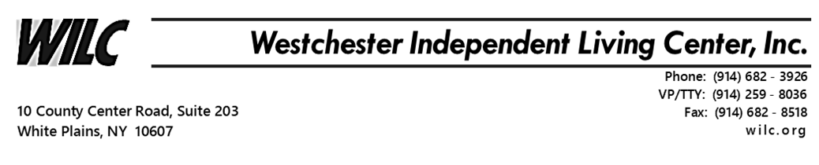

Social Media Awareness
The Minority Outreach program is working remotely to provide ongoing service during this time of crisis. Due to COVID-19 and the “Stay Home” social distancing risk factors, we will be conducting our Social Media Awareness program via Zoom Meetings.
Minority Outreach Program will hold our Social Media Awareness workshop
on Tuesday 05/19/20, Wednesday 05/20/20 & Thursday 05/21/20 from 10am – 12pm.
Wifi or internet service and a smart phone, tablet or desktop computer is required to join. Although a camera is not required, your interaction and participation is needed to complete.
Social media has become the new a way of the world. If you are having trouble getting adjusted to modern technology, please join our social media awareness workshop. Our goal is to show you how it is used in our common everyday life. It can also be used to earn a living, self-educate “DIY” and entertainment.
Join WILC’s Minority Outreach Program Social Media Awareness Zoom Meeting by registering below.
http://eepurl.com/gYIsY1
For any questions concerning registration email me at JMalloy@wilc.org

Regards,
James Malloy,
Minority Outreach Specialist/Re-entry Programming
Westchester Independent Living Center
10 County Center Rd, 2nd Floor White Plains, NY 10607
Tel. (914) 682-3926 ext. 2102 Fax. (914) 682-8518
JMalloy@wilc.org
Website: www.WILC.org

