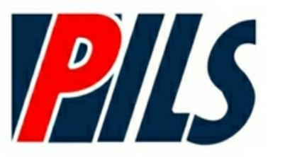
Putnam Independent Living Service
A satellite office of Westchester Independent Living Center

The Lower Hudson Regional Special Education Technical Assistance and Support Center
and Putnam Independent Living Services
Present

Graduation Options for Students with IEPs

Join us as we examine all graduation and exiting options for students with disabilities
including the 4+1 Pathway, the appeal process, local diploma options, Superintendent Determination, the Career Development and Occupational Studies (CDOS) Commencement Credential and the Skills and Achievement Commencement Credential

Please Note: This workshop is intended as an overview only. Participants will learn about graduation options, updates to diploma requirements and eligibility requirements for the CDOS and Skills credentials.

Presenter: Stephanie Wozniak, MS, LMHC, Transition Specialist
Lower Hudson Special Education Technical Assistance & Support Center, PNW BOCES

Date and Time: Tuesday, March 20, 2018
12 p.m. - 2 p.m.

Location: Putnam Independent Living Services
1441 Route 22, Ste 204
Brewster, NY

Questions: Jessica Baumann, 845-228-7457, ext. 1108 or jbaumann@putnamils.org

To Register Please Click HERE

If you need any special accommodations, please let us know two weeks in advance

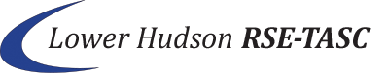
Putnam Independent Living Services
1441 Route 22, Suite 204
Brewster, NY 10509
845.228.7457

Westchester Independent Living Center
10 County Center Road, 2nd Floor
White Plains, NY 10607
914.682.3926

